**Custom Development Tools**

The software team also builds and maintains custom development tools. These tools are used by the entire team to test and tune drive systems, actuators and sensors. The Stryke Force Grapher application allows the team to log and analyze the robot performance and perfect the tuning by plotting data received from the RoboRIO. Stryke Force is able to chart almost any data possible from the RoboRIO.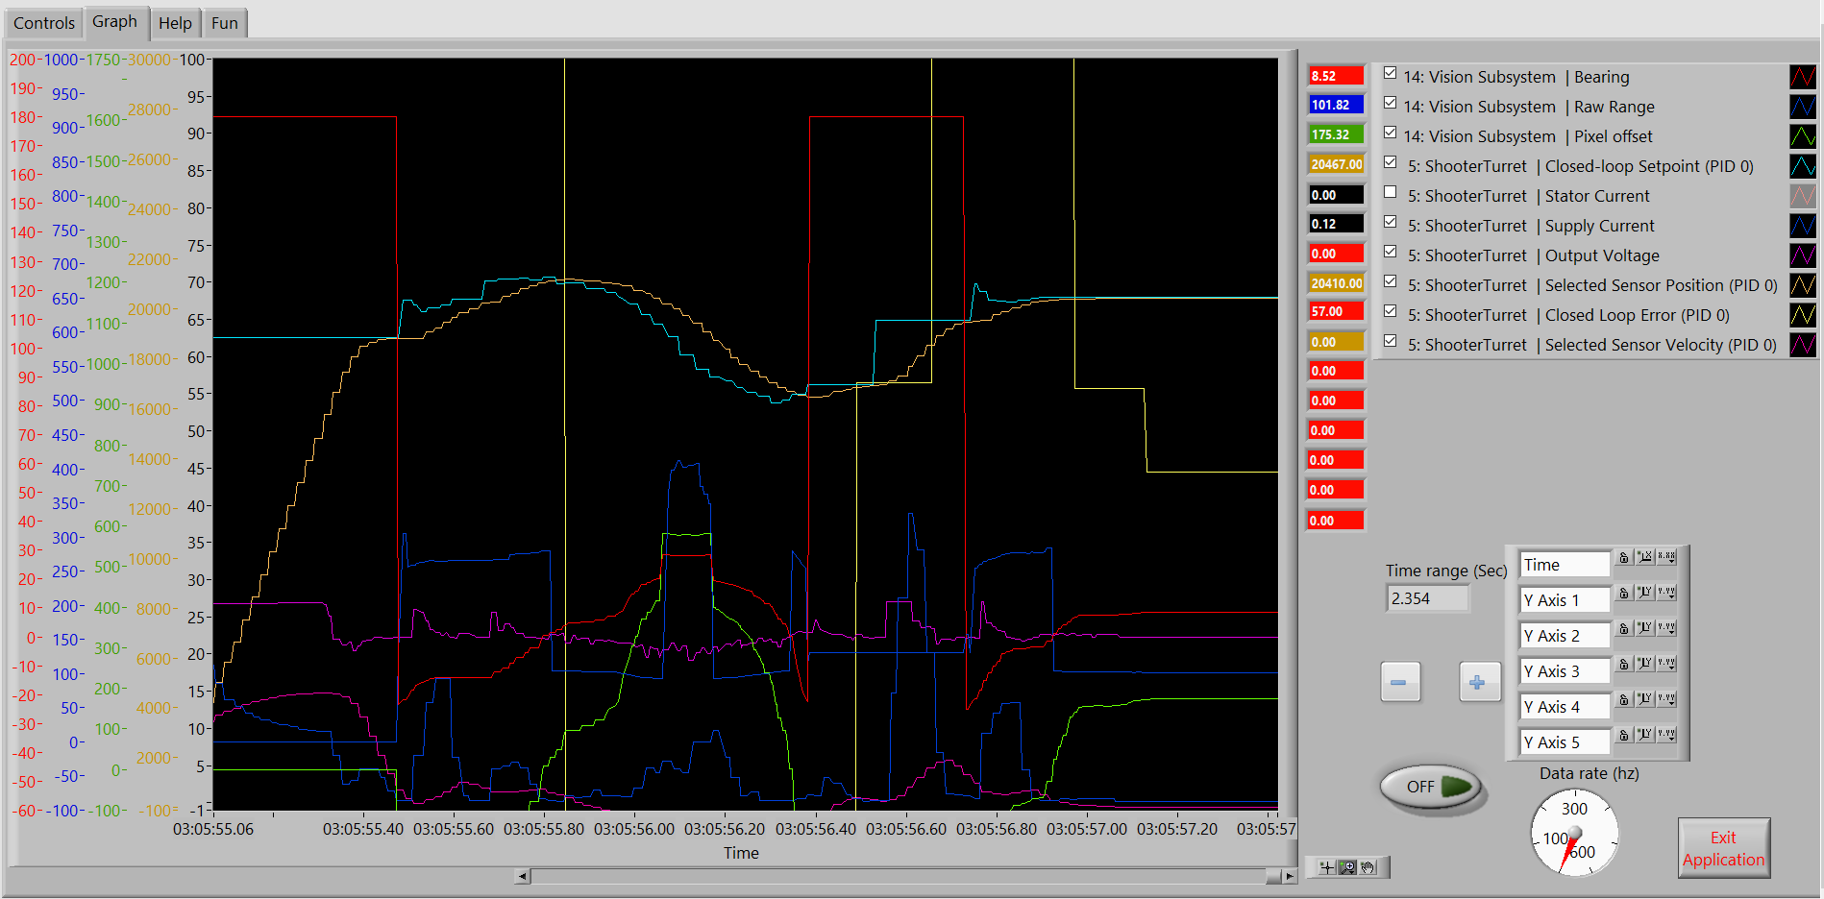

Third Coast Telemetry (TCT) and the Grapher applications provide Stryke Force with deep insight into robot performance and are invaluable to the development process.

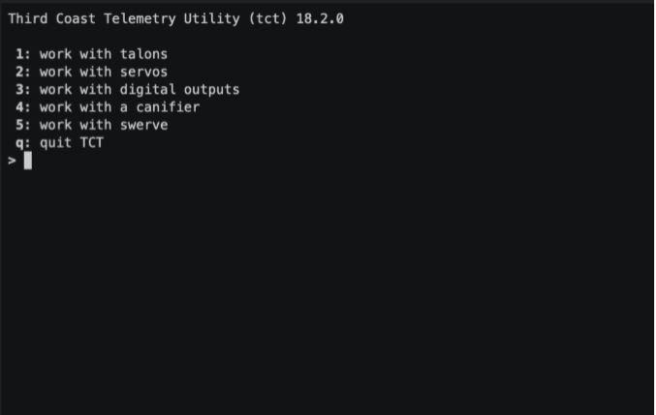

We are pleased to make TCT and the Grapher available as open source at https://github.com/strykeforce. More resources are available at https://www.strykeforce.org/resources



**Team 2767 Stryke Force**

Est. 2009

Kalamazoo, MI

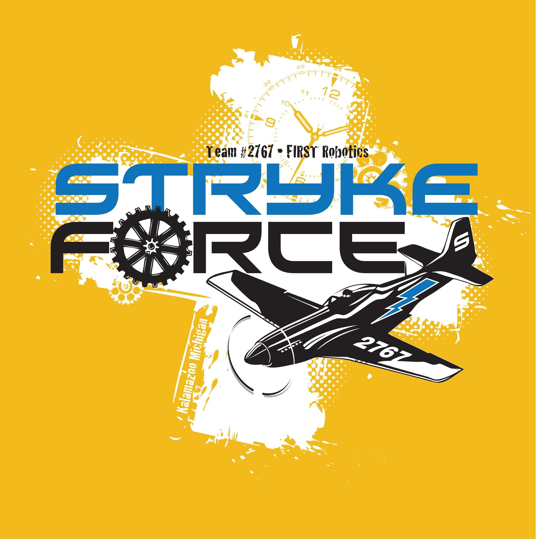

**Software**

**2023**

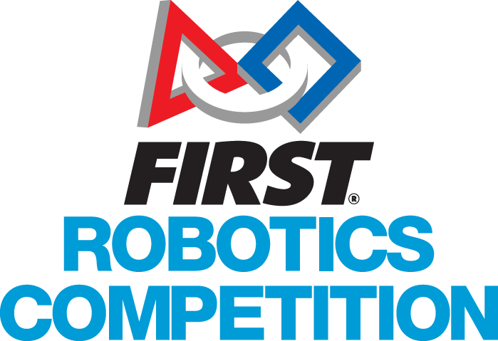

### Software Designed for Drivers

Stryke Force is proud to present the control system software for NAME IS NOT CHOSEN—our robot competing in FIRST® RAPID REACT presented by The Boeing Company. We strive to meld high-performance hardware with custom software to provide our drive team with the best robot software possible. Our Third Coast Swerve Drive has historically provided unmatched maneuverability and response. Our highly optimized parallel movements enable us to deliver game pieces faster than ever before.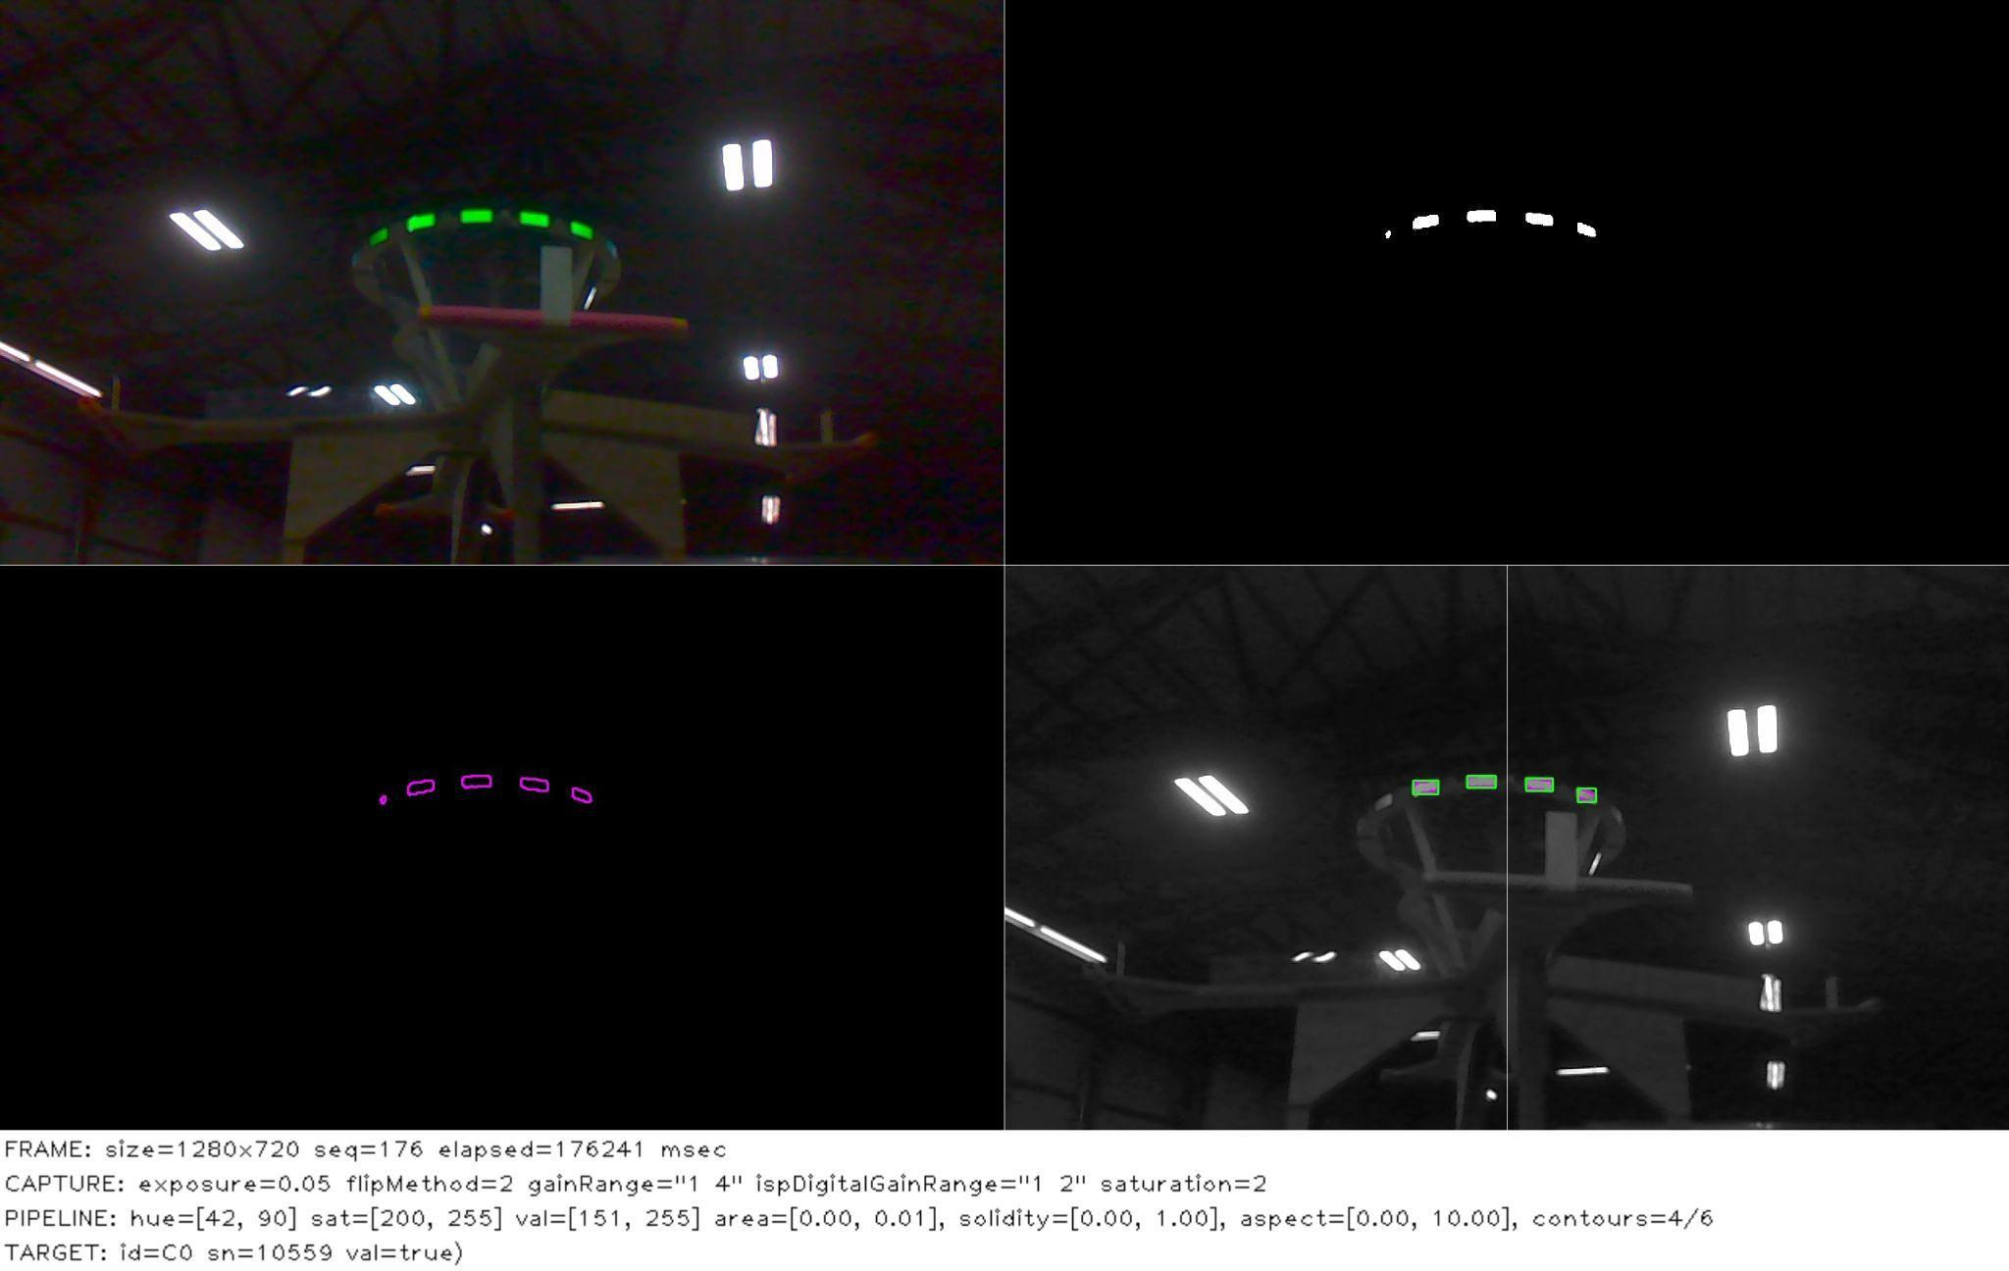

### Precision Control Systems

Stryke Force delved deep into motion profiling this year. Using the CTR-Electronics Talon SRX Motion Magic functionality, the programming team controls the motion profile using acceleration, velocity, current limit, and PID parameters. This feature in the software allows the robot to make precise and repeatable movements in all subsystems.

**Auton routines**

We also have many different autonomous routines, making for high cooperation with our teammates. We are striving to make our routines compatible with other teams.

#### Auto-place and pick-up

The software team placed a heavy focus on auto-placing our game pieces. To ensure maximum accuracy (because it’s embarrassing to drop pieces), we’re implementing computer vision (CV) to guide our system automatically. Since vision processing significantly affects CPU performance, we decided to use a raspberry pi 4 co-processor. The system first finds our location by having photon vision scan for apriltags(similar to QR codes, but used for positioning), then using this information to move to the correct location. From there, all that’s necessary is to move the arm and drop the piece.

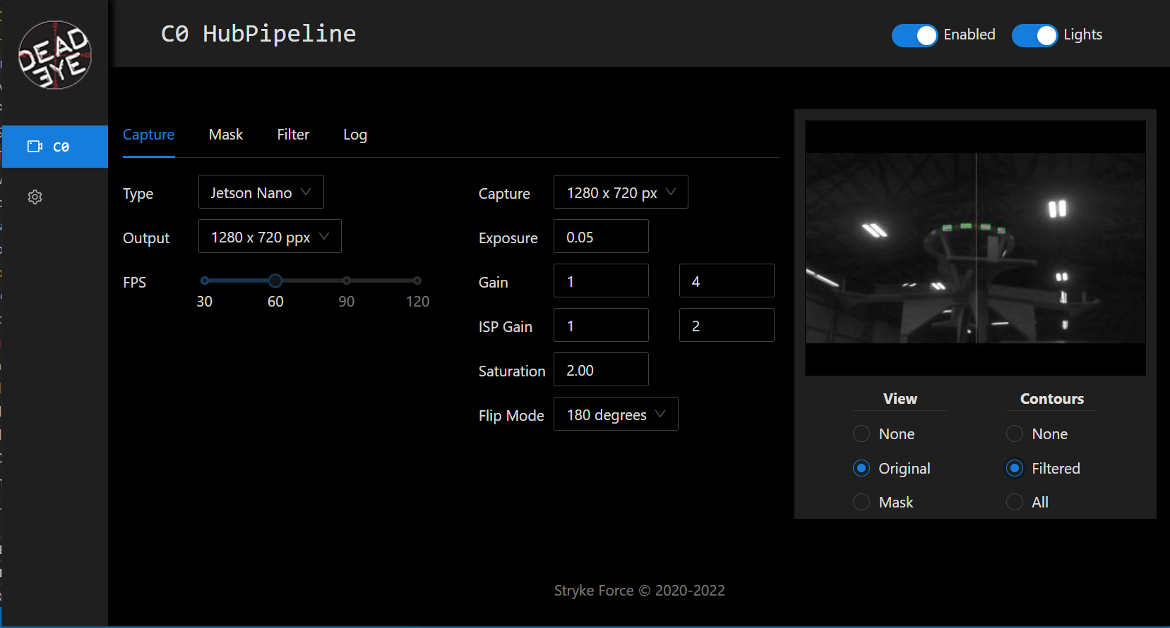

#### Indicator lights

This year, we decided to have lights on top of the elevator for messaging. Our uses include signaling if our robot sees an apriltag, if we have a game piece, and what piece we want at the substation.

**State Machines**

Stryke Force has decided to implement state machines as a way to further streamline robot code. In doing this subsystems can talk about what they are doing in a much easier way. This communication allows for state specific commands that handle most if not all repeating logic. Furthermore, this strategy allows for easier transition between the complicated code necessary for each state and its duties.

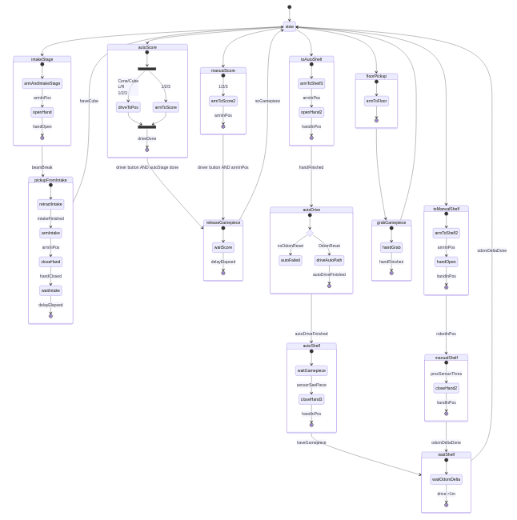

The two subsystems that implemented this new strategy were the robotState and arm subsystems. Before and throughout development we utilized easy to read flow charts as seen above as a structure to follow for our code. In short, this strategy of structuring code allowed us to make our code easier to read and more friendly to the human brain.